**Map Tour Content: James Cook’s First Voyage**

**1st Location:**

**Media: Plymouth**

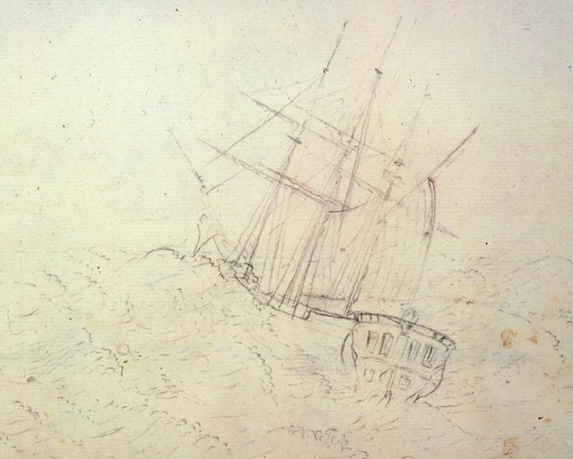

**Information:**

**Name:** August 1768, Departure from Plymouth Dock (Now known as Devonport)

**Caption:** The Royal Society Petitioned King George III to finance a scientific expedition to the Pacific to study and observe the 1769 transit to Venus across the sun in order to measure the distance from the Sun to the Earth and secretly search for the unknown Great Southern Continent (terra australis icognita). Captain James Cook, a naval officer with a background in mathematics and cartography, was appointed as commander of the expedition. Cook departed from Plymouth (now known as Devonport) on August 26, 1768 in the Endeavor ship, carrying 94 people and 18 months of provisions. Among the notable people on board included Charles Green, Assistant to the Astronomer Royal, and Sir Joseph Banks, a naturalist, botanist, and patron of the natural sciences.

**Location:** 50.377, -4.176

__________________________________________________________________

**2nd Location:**

**Media: Madeira**

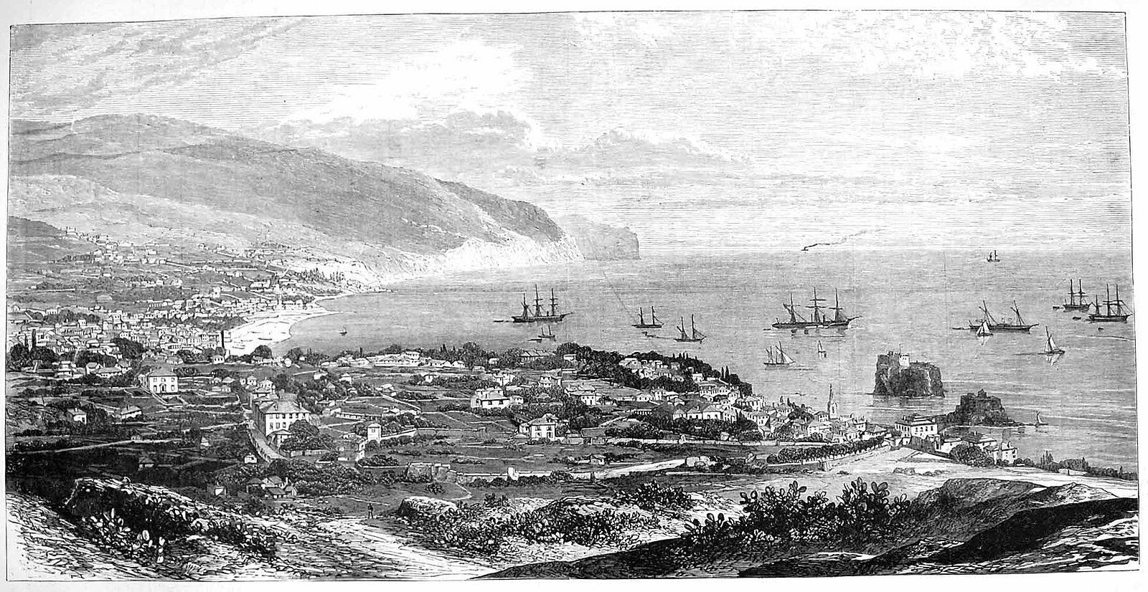

**Information:**

**Name:** September 1768, Arrival in Funchal Madeira

**Caption:** On their journey, they experienced heavy showers of rain, drowning between 3 and 4 dozen of their poultry of food. The Endeavor stopped in Funchal Madeira, where it had been arranged for Cook to pick up a quantity of wine, and to replenish their food. When anchoring, the first casualty occurred. The master's mate, William Weir, became entangled in the rope and was carried down to the bottom of the ocean with the anchor. He was dead when the anchor was hauled up. After leaving Madeira, the Peak of Tenerife was seen and the Cape Verde Islands.

**Location:** 32.651111, -16.909722

**3rd Location:**

**Media: Rio de Janeiro**

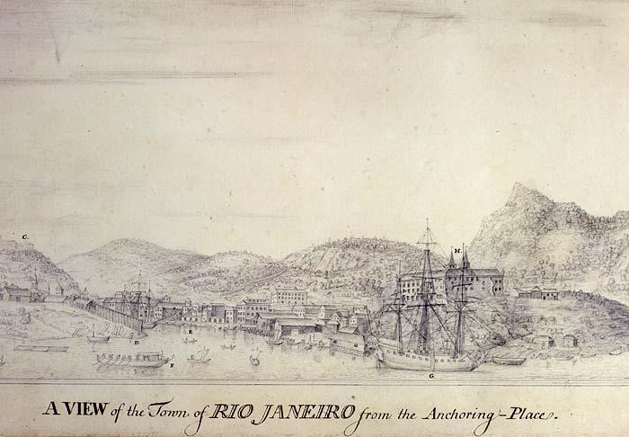

**Information:**

**Name:**  November 1768, Rio De Janeiro

**Caption:** The ship reached Rio de Janeiro, where a delay occurred because the ship was mistaken for a pirate vessel. English buccaneers in the guise of King's ships were not unknown at the time. By December 1769 the misunderstanding was finally dealt with and the ship was on its way to Tierra del Fuego.

**Location:** -22.908333, -43.196389

**4th Location:**

**Media: Tierra de Fuego**

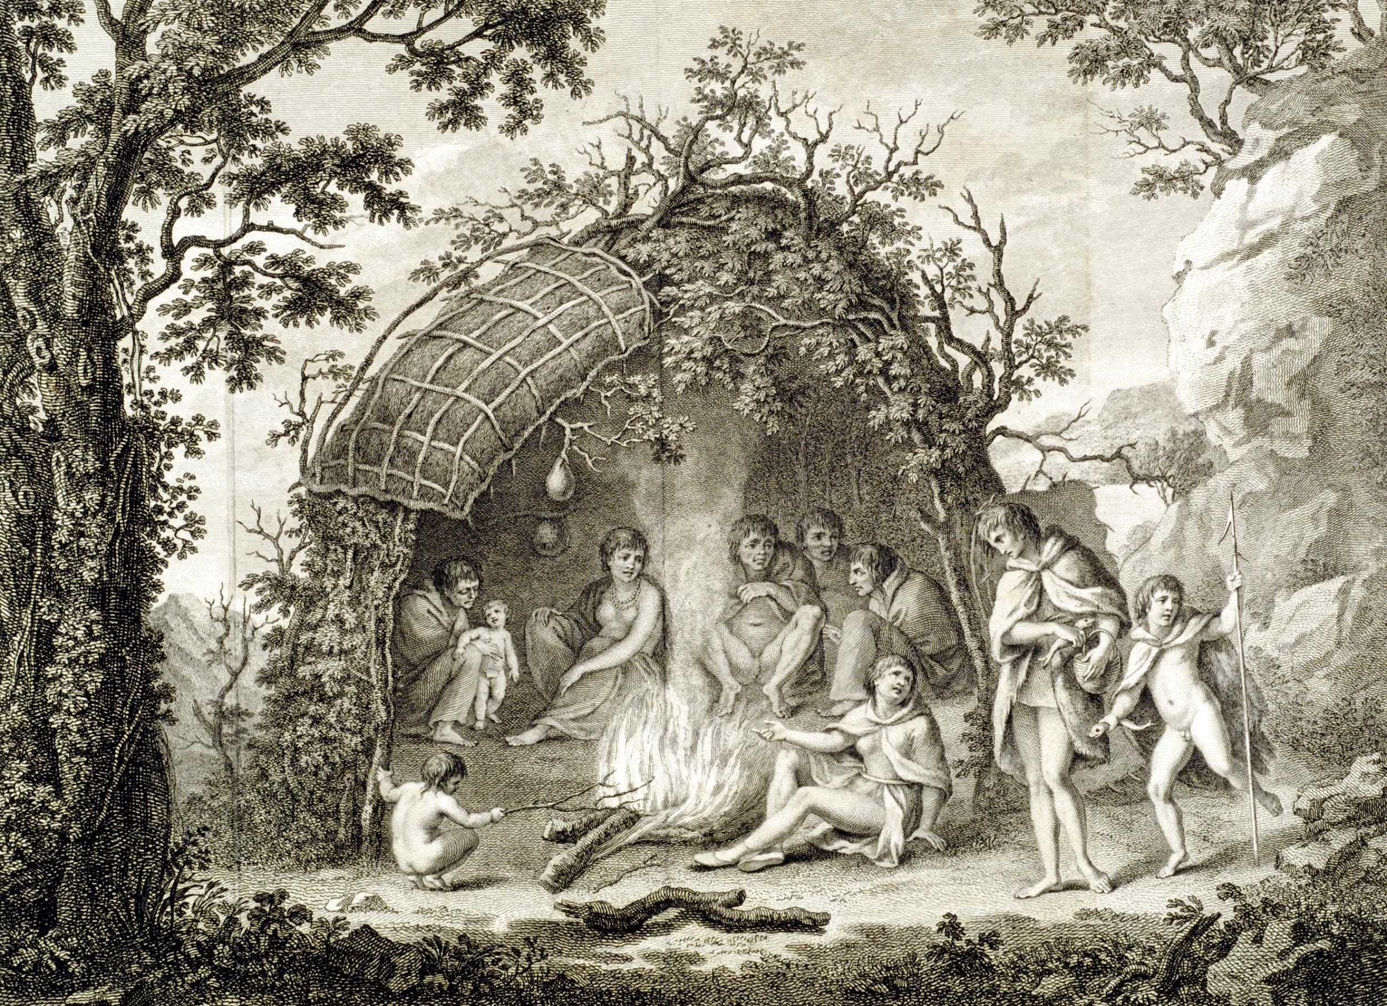

**Information:**

**Name:** January 1769, Tierra del Fuego

**Caption:** The Endeavor was out of sight of land for over a month, the first that came into view being the coast of Terra del Fuego, south of the entrance to the Magellan Strait. Maneuvering the ship between the western point of Terra del Fuego and the islands was difficult for a clumsy ship like the Endeavor. Though it took four days for the ship to get through the Magellan Strait, Cook was able to take observations of the sun at this time. They eventually anchored their ship at the Bay of Success, where Cook's men went ashore and met the local people there. Joseph Banks's and twelve other men from the ship explored the island and collected botanical specimens on the land but two servants, Thomas Richmond and George Dorlton, died of exposure in the snow and cold. Leaving Tierra del Fuego, the Endeavour rounded Cape Horn and sailed into the Pacific Ocean.

**Location:** -54, -70

**5th Location:**

**Media: Tahiti**

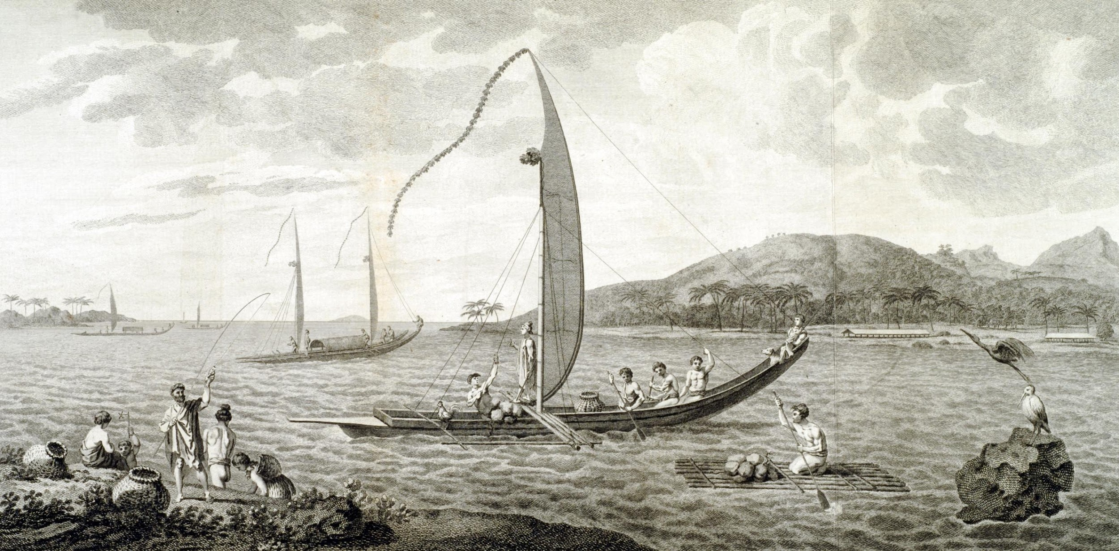

**Information:**

**Name:** April 1769, Tahiti and the Observation of the Transit of Venus

**Caption:** After sailing 5036 miles, the Endeavor passed the island of Mehetia, where Cook and his passengers spotted Tahiti in the distance. The boat anchored in Matavai Bay on April 13, 1769, where they were welcomed by Tahitians. Cook and his crew experienced good relations with the Tahitians and made friends with Tupaia, a Tahitian priest. Tupaia acted as an interpreter when they came into contact with other Polynesian inhabitants and helped Cook create a map of the Pacific Islands. In Matavai Bay, Cook established a fortified base, Fort Venus, from which he observed the Transit of Venus on June 3, 1769. During this transit, Cook recorded the various phases of Venus. Having set out what they were meant to do in Tahiti, Cook departed the islands in search for the mysterious unknown Great Southern Continent.

**Location:** -17.666667, -149.416667

**__________________________________________________________**

**6th Location:**

**Media: New Zealand**

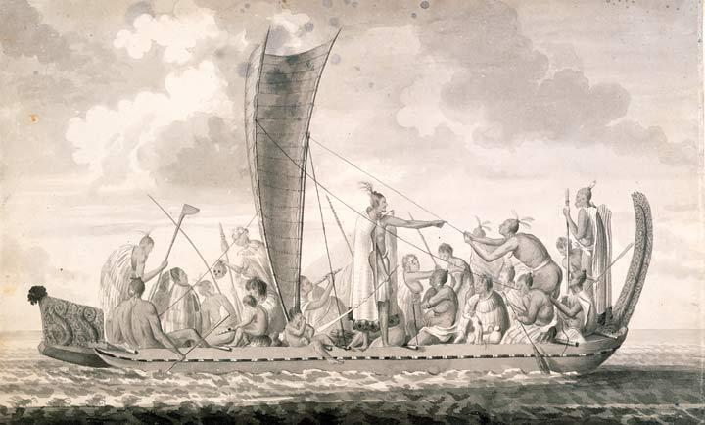

**Information:**

**Name:** October 1769, New Zealand

**Caption:** The Endeavor sailed in search of the Southern Continent from August-October 1769 before turning west towards New Zealand. On October 9, 1769, Cook and his crew landed on the east bank of the river Waipoua, where they first encountered the natives of Maori. The Maori performed fierce dances, or hakas, in attempts to threaten and challenge the ship's crew. Some of the warriors were killed when Cooks men defended themselves. After returning to the Endeavor, the crew found themselves being followed by two canoes which were crossing the bay and were able to get quite close before they were observed. The Maoris used their paddles as weapons to attack The Endeavor. This placed Cook and his crew in an awkward position as they had hoped to negotiate with them. In self-defence, Cooks men had to fire and four of the Maoris were killed. After much violence and back and forth battles, relations with the Maoris eventually improved and Cooks crew was able to trade with the Maoris for fresh supplies. While exploring different bays and rivers, Cook and his crew circumnavigated New Zealand and were the first to accurately chart the whole of the coastline.

**Location**: -35.653122, 173.507642

**7th Location:**

**Media: Australia**

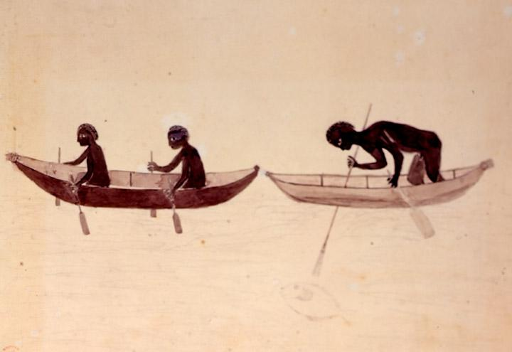

**Information:**

**Name:** April 1770, Australia

**Caption:** The Endeavor left New Zealand and sailed along the east coast of Australia, heading north. On April 29th, Cook charted the east coast of Australia from Point Hicks to Botany Bay. The ship struck the Great Barrier Reef and was badly damaged. Repairs had to be carried out in the river over a period of five months. According to Cook's journals, the inhabitants of Australia were different from the people he had encountered in the other Pacific islands who had lighter skin. In Australia, Cook and his crew witnessed their first sight of a kangaroo, among other unknown creatures at the time, including the platypus.

**Location:** -37.803056, 149.275556

**8th Location:**

**Media: Batavia**

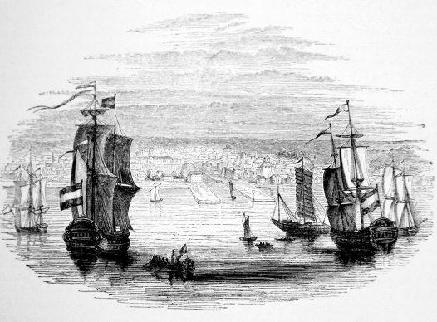

**Information:**

**Name:** October 1770, Batavia, Dutch East Indies (now known as Jakarta)

**Caption:** After leaving Australia, The Endeavor stopped in Batavia for further repairs. While in Batavia, Cook determined from his travels, maps, and descriptions of the islands of the East Indiana Archipelago that there was no further discoveries which he could make and there was no unknown Great Southern Continent (terra australis icognita). Although Cook's crew had been fairly healthy almost free from scurvy up until they reached Batavia, many of them caught dysentery and typhoid and died. After 2 and1/2 years, Cook and his Crew were finally on their way home.

**Location:** -6.2, 106.816667

**9th Location**

**Media: Deal, Kent (England)**

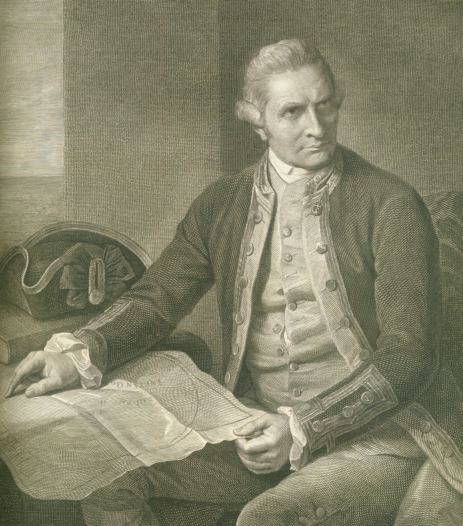

**Information:**

**Name:** July, 1771 Deal, Kent (England)

**Caption:** Now on their way back to England, Cook and his crew rounded the Cape of Good Hope and sailed up the English Channel, passing Beach Head. The Endeavor anchored in the Downs, where Cook and his crew went ashore at Deal, Kent. His return was unexpected. Many at home thought Cook and his crew had gone missing and were never to be seen again. Many were shocked to learn that it was the Endeavor that was back from circumnavigating the globe. There were 56 men left of the 94 who had left England almost 3 years ago. Captain James Cook's return home was front page news in all the newspapers across England.

**Location:** 51.2226, 1.4006